FBI Clearances: https://www.pa.cogentid.com/index.htm
If you must complete the FBI Clearance (and associated fingerprinting), online registration can be found at www.pa.cogentid.com
The agency you are volunteering with will determine which department you need to get your FBI clearance through (PA Dept. of Ed. or PA Dept. of Human Services). Ask the volunteer agency which one they require BEFORE you proceed, because the clearance results are NOT interchangeable.
Note: If you have been a PA resident for the previous 10 consecutive years, you do NOT necessarily have to complete the FBI Clearance. Instead, you can sign the PA Residency form found at http://keepkidssafe.pa.gov/cs/groups/webcontent/documents/document/c_160267.pdf
The cost of this clearance is $28.50.
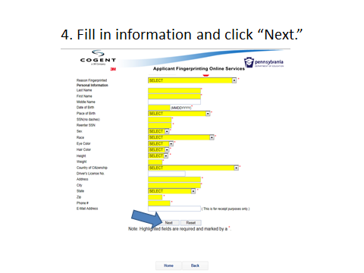
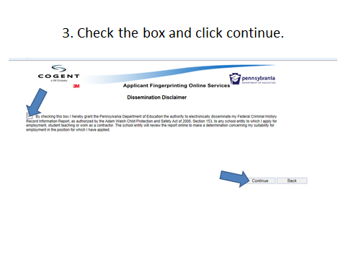
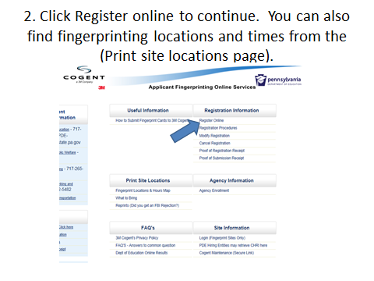
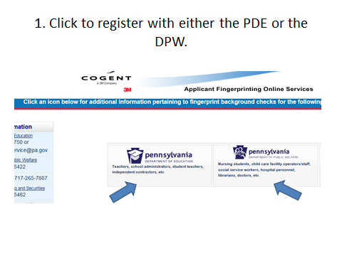
[Type a quote from the document or the summary of an interesting point. You can position the text box anywhere in the document. Use the Drawing Tools tab to change the formatting of the pull quote text box.]
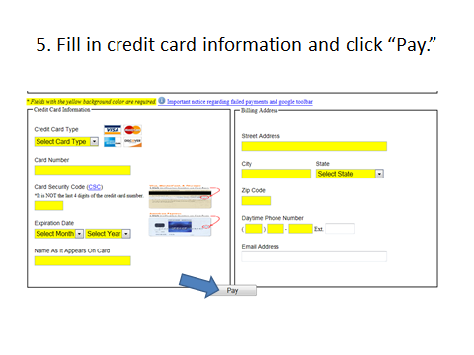
6. Print application registration. Take printed application registration and photo ID to fingerprinting location to complete FBI clearance. Fingerprinting can be done at the Elizabethtown Public Library after
September 28, 2015.

