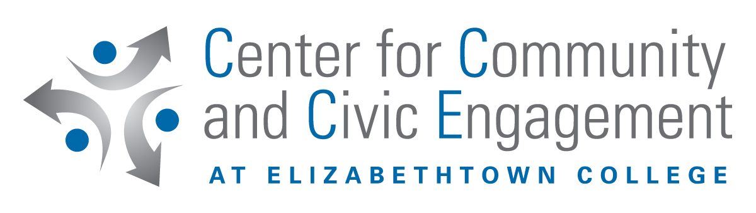
Community-Based Learning Pre- Experience Evaluation

PLEASE FORWARD A COPY TO CCCE

Course:

1. I am a year – old male

female

2. I am a: first year student

sophomore

junior

senior

other

3. I am working toward a major.

4. This course fulfills for me a requirement for my major.

requirement for my minor.

elective general education requirement

personal interest

5. I knew part of this course included community-based learning before I registered for it.

yes no

6. I chose to take this course because: (please check all that apply)

the description in the catalogue was interesting

a fellow student recommended it

a faculty member recommended it

it fit my time schedule and I needed the credit

I was interested in the community-based learning component

it is necessary for my major or minor

other

7. If community-based learning is optional in this course, are you choosing to participate?

yes no

Please answer the following questions even if you are not participating in community-based learning

8. How do you feel about the community-based learning component of this course?
(Please circle the response closest to your feeling.)

very positive somewhat positive somewhat negative very negative

9. Do you think that community activities are a valuable and appropriate learning component within this course?

yes no

10. What, if any, reservations do you have about participating in community-based learning?

11. Are any of the community sites selected for the course appealing to you?

yes no

12. Are there enough options for the community sites?

yes no

13. If you are participating, how many hours do you expect to be involved in community service this semester through your placement for this course?

hours

14. Are you currently active in:
Hours per week

a religious organization

intramural sports

intercollegiate sports

student government

a campus interest group

community service

other extracurricular activities

15. Are you currently employed?

yes no

If YES: how many hours a week do you usually work? Hours

Do you work on-campus?

yes no

16. Before your involvement in this course, have you ever participated in any volunteer work or community service?

yes no

If YES, did you participate (please check all that apply to you)

before high school

while in high school

while at (name of college)

while at another college or university

other

If YES, was it conducted through

a school based program

a religious organization

your own initiative

(name of office)

other

If YES, briefly describe your service experience (name of organization, volunteer responsibilities and tasks, etc.)

17. Have you ever participated in an internship?

yes no

If YES, was it at (please specify)

a non-profit organization

a for-profit organization

government agency

other

18. Do you expect to spend time volunteering after this semester is over?

yes no

Using this rating scale, please answer the following:

very extensively extensively somewhat very little none
5 4 3 2 1

To what extent have your experiences outside of college this far enabled you to:
Learn about a culture/cultures different from your own
Critically reflect upon your own values and biases
Improve your written communication skills
Improve your oral communication skills
Improve your critical thinking/analytical skills
Improve your problem solving skills
Understand how communities and cities work or function

Comments on the above section:

To what extent has your college experience this far enabled you to:
Learn about a culture/cultures different from your own
Critically reflect upon your own values and biases
Improve your written communication skills
Improve your oral communication skills
Improve your critical thinking/analytical skills
Improve your problem solving skills
Understand how communities and cities work or function

Comments on the above section:

Adapted from Community Service at Augsburg College by permission of Eastern Michigan University, Office of Academic Service-Learning

