PA Child Abuse History, Criminal History, and FBI Clearances
All three clearances can be found at: http://www.dhs.state.pa.us/findaform/childabusehistoryclearanceforms/index.htm

- PA Child Abuse Clearance: https://www.compass.state.pa.us/CWIS
For your PA Child Abuse History Clearance, you have 3 options: Mailing your application (wait time for the results is approx. 4 weeks), driving to the Child Abuse Background Check site (wait time is approx. 15 minutes), OR complete online process). Costs $10.00.
- Mailing Option: Fill out the form for the PA Child Abuse History Clearance. Include a $10.00 money order (that can be purchased at a location such as Giant or Turkey Hill). Cash or personal checks are not accepted.
- Driving Option: Driving directly to the Child Abuse Background Check site. The building is in Harrisburg (less than an hour drive). Take completed Child Abuse form, your photo ID, and $10.00 money order (that can be purchased at a location such as Giant or Turkey Hill) with you. Cash or personal checks are not accepted. See driving directions below.
- Online application: https://www.compass.state.pa.us/CWIS Step by step directions are provided below if needed.
Driving directions to the Child Background Building:
- Route 283 W to 283N to 83 N
- 83 N to 81 S
- Take Exit 69 Progress Avenue and bear right to go South on Progress Avenue
- At 4th light, make a right onto Elmerton Avenue (CVS is on the right)
- Continue on Elmerton Avenue, at 4th light make a left onto Sycamore Drive
- Continue on Sycamore drive until you get to a BIG speed bump
- After the speed bump you will see a big, red brick building on the right. Parking lot is on the left. You can park anywhere in the lot.
- Walk across Sycamore to the brick building (53 Hillcrest).
- Inside the entrance there is a phone on the wall. You want the phone number that is for the Child Background Check.

They are open 8:30 am – 11:45 am and 1 pm – 4:45 pm Mondays thru Fridays.

Mailing or driving option:
http://www.dpw.state.pa.us/ucmprd/groups/webcontent/documents/form/s_001762.pdf
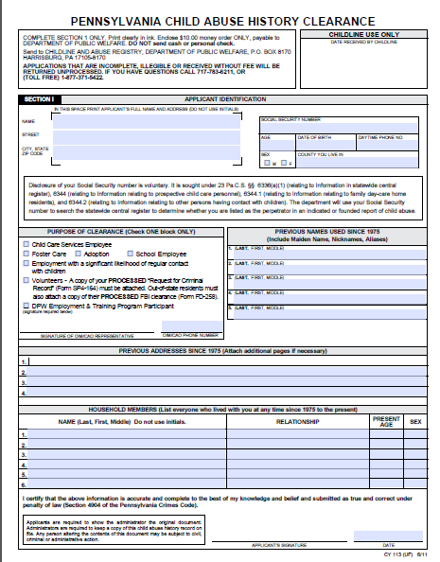
Complete the information in Section 1
Purpose of Clearance: Unless an agency told you to check something else, check “Employment with significant likelihood of regular contact with children”
Effective December 31st, 2014: Copies of PA Criminal History Background Check or FBI clearances are no longer required to submit child clearances.
Do not forget to sign and date the bottom of the form.

Online option:
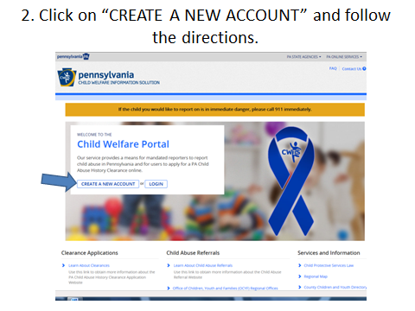
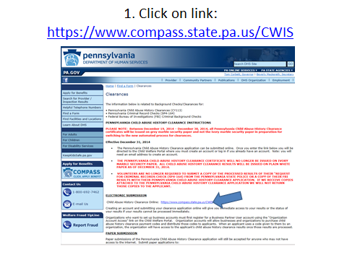

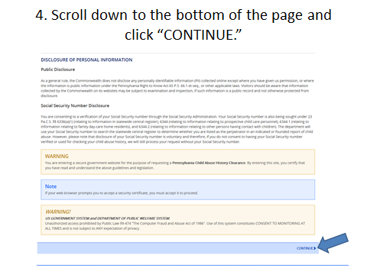
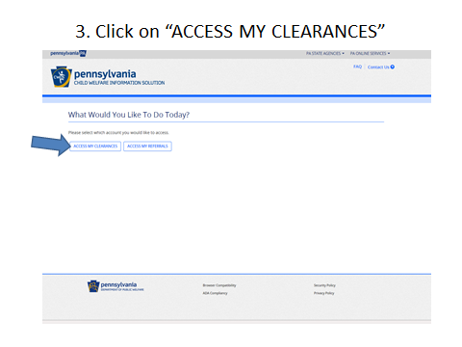

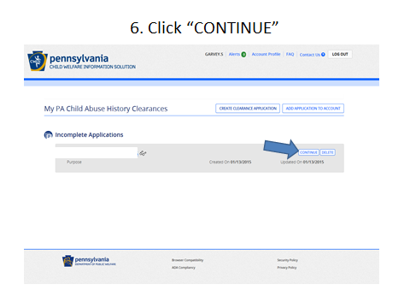
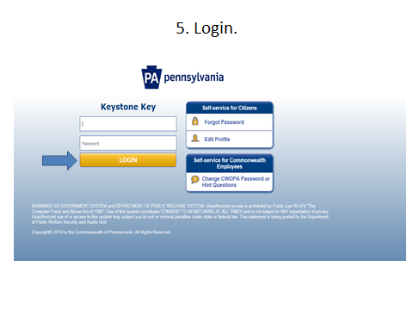

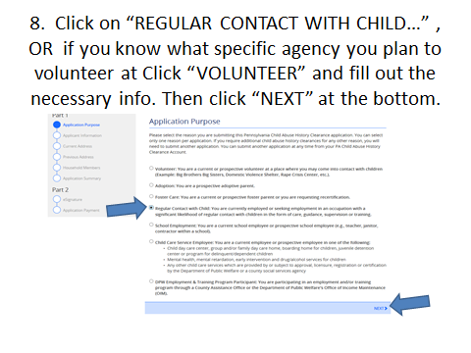
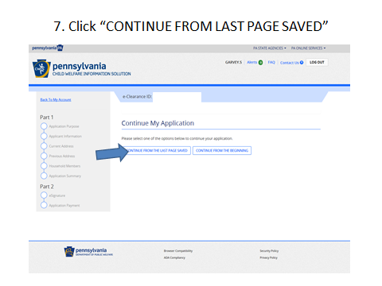

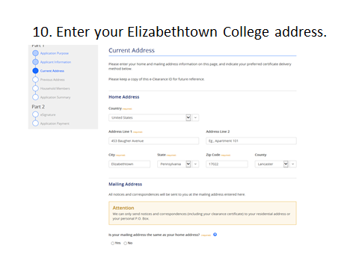
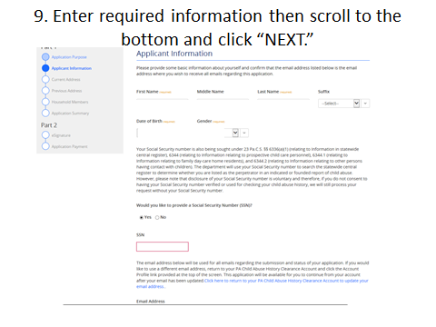

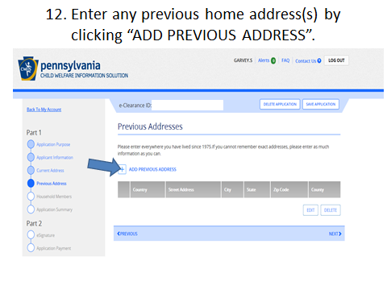
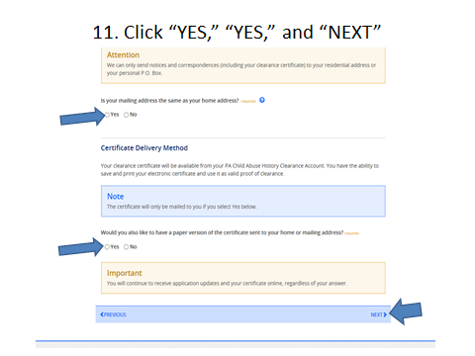

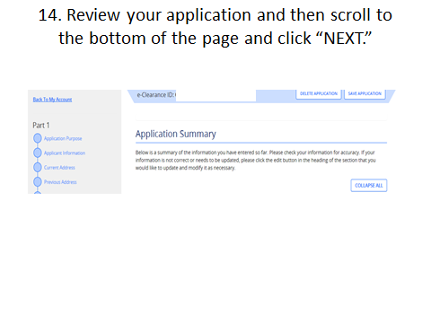
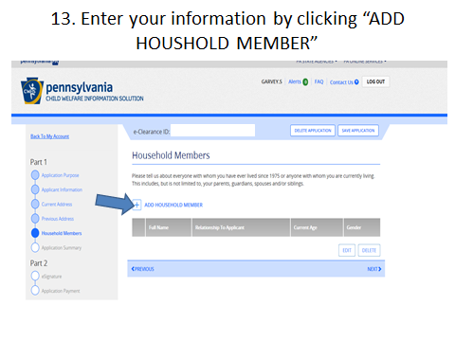

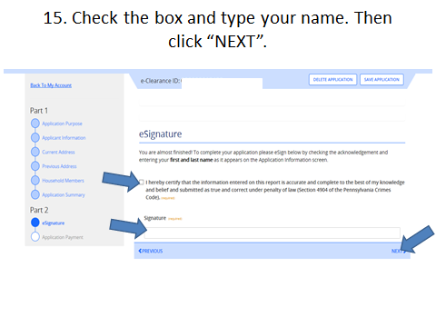
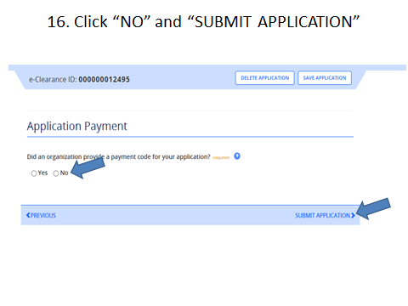

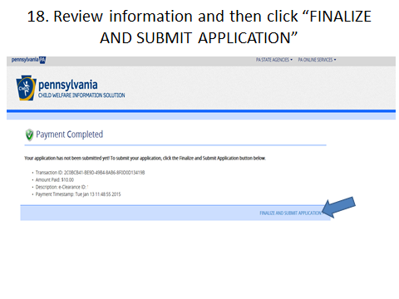
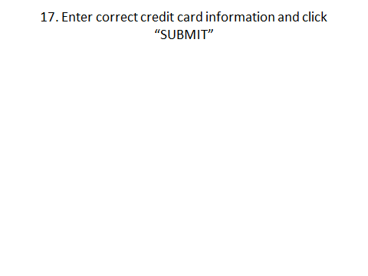

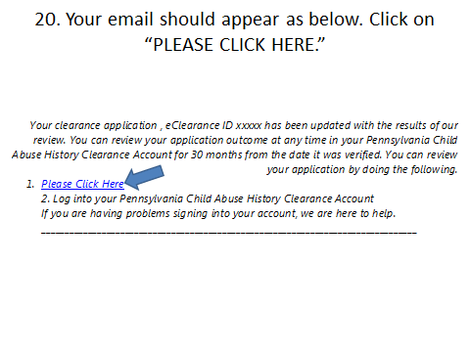
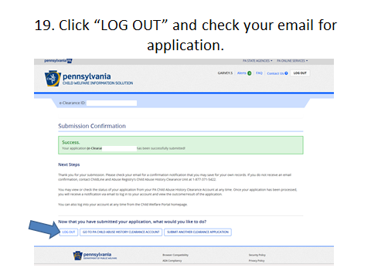

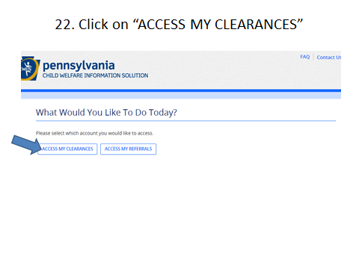
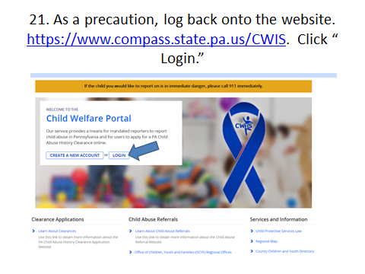

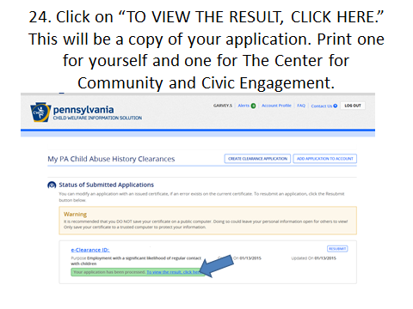
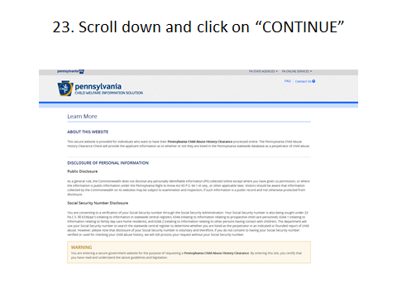

- PA Criminal History Records Check: http://epatch.state.pa.us
Complete online application. Credit card required, cost $10.00. Write down the control number so you can access your record if needed at a later date.

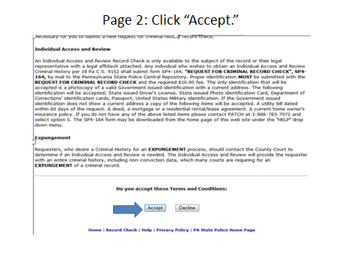
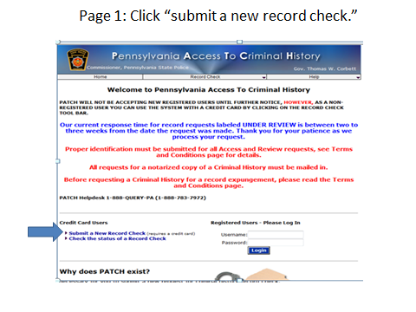

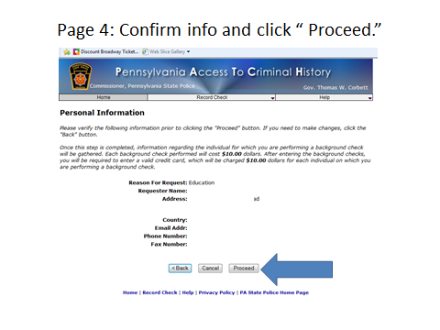
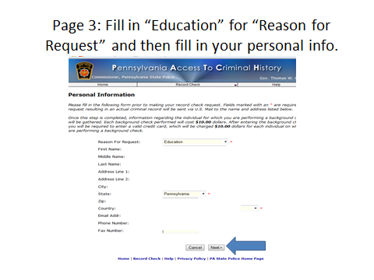

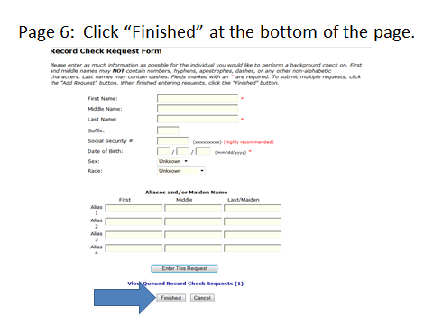
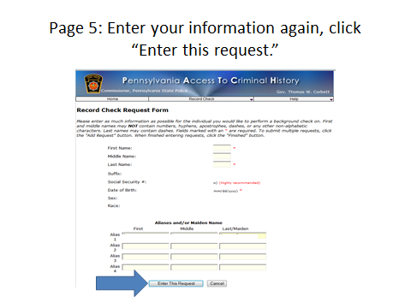

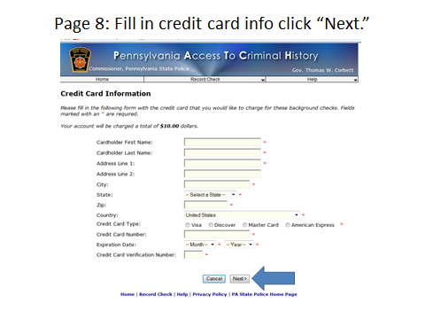
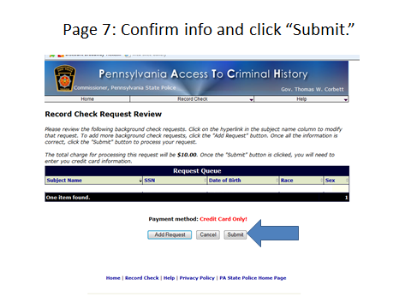

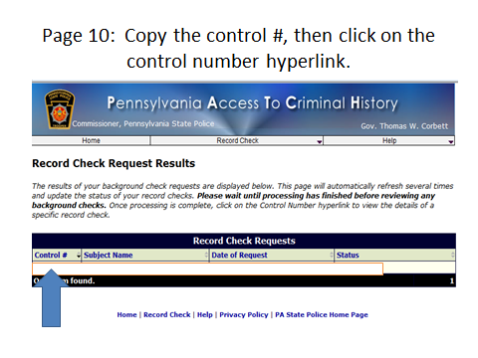
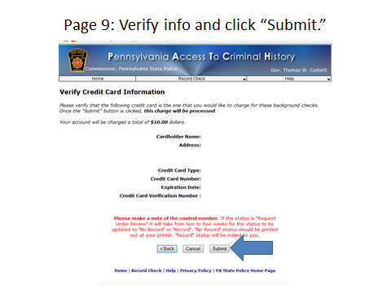

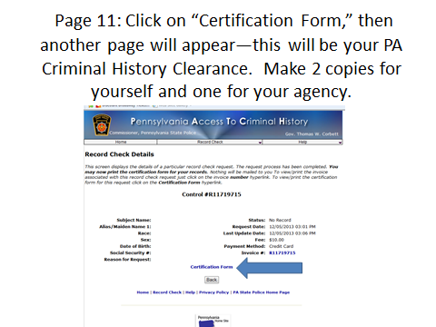

- FBI Clearances: https://www.pa.cogentid.com/index.htm
Please check with your agency before completing the application. Some agencies require results from the Dept of Education (PDE), while others require the Department of Welfare (DPW) results. Cost: $28.75.
