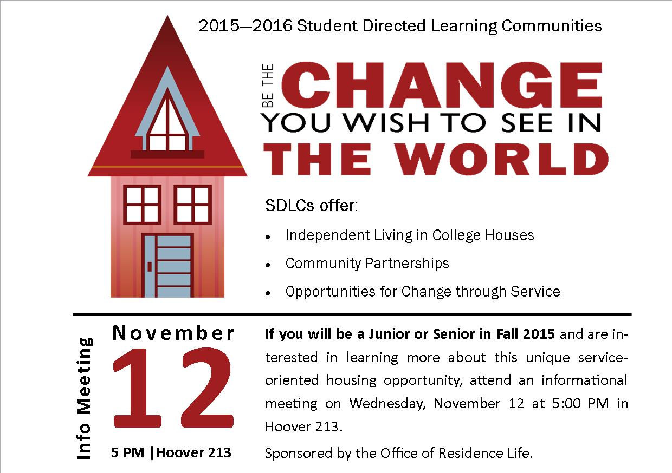

**Student Directed Learning Communities**

**2015 – 2016 Application**



**Please note that all applicants MUST register for a LOTTERY NUMBER. Applicants MUST also fill out any Residence Life applications for Specialty housing OR ILUs while going through the SDLC application process if these are your secondary housing choices. Please note all Residence Life housing deadlines regarding these applications while are you applying.**

**Student Directed Learning Communities**

**2015 – 2016 Application**

**Please read and follow all instructions carefully**. Most SDLCs are for four (4) people; however, two (2) groups of five (5) students and one (1) group of three (3) students will be accepted into the program. **Completed applications are due by 5:00 PM on Friday, February 27. ALL** sections of the application must be received at the same time in order to be considered. Late applications will not be accepted. Only one application should be complete per group.

**Completed applications should be EMAILED to** [**vieldhousek@etown.edu**](mailto:vieldhousek@etown.edu) **by 5:00 PM on Friday, February 27.**

Please contact Kristen Vieldhouse at [vieldhousek@etown.edu](mailto:vieldhousek@etown.edu) with any questions.

IMPORTANT INFORMATION: IF YOU ARE HAVING DIFFICULTY WITH THE NUMBER FORMATTING IN THIS FORM, TRY HOLDING SHIFT+ENTER TO CHANGE LINES WITHIN THE FORMAT BOX.

**PART 1:** Group Information

*Information in this section must be completed together as a group.*

1. **Basic Information**
2. Name of SDLC_     _
3. Names of SDLC members (3-5):










4. Applicant who will be the “point-person” for your group:
   1. Name:
   2. Etown email address:
5. Please answer the following questions as a group.
6. What is the service learning or advocacy topic your house wishes to explore?
7. Mission of SDLC
8. Describe the service program(s) you will do each semester (identify organization(s) you will work with and what the program will consist of).
9. Please provide the names and contact information of the individual(s) in the organizations with whom you will work with on these projects.
10. How do your service projects tie into the theme your house wishes to explore?
11. In what ways and capacity will your SDLC continue and implement reflection for the service projects that are completed?
12. Please provide a signed learning mentor form from a faculty/staff member who is willing to serve as your learning mentor. (Please note that this person will need to commit to meeting with your group at least twice a semester).

# SIGNATURE PAGE: All Group Members Please Read and Sign

*Please print this page and turn it in separately to the Office of Residence Life by the February 27 deadline.*

By signing this page, each member of the applicant group is confirming that all information in this application is correct and original to the group. Applicants are also confirming that they will uphold by all Elizabethtown College policies and follow any additional instructions or decisions regarding SDLCs made by the Office of Residence Life. These decisions include the final determination of SDLC house assignments.



***\*Please note that incomplete or late applications will not be considered.***

**PART 2:** Individual Applicant Educational Plan

*Information in this section must be completed by EACH applicant separately. This section should be submitted once for each applicant. All responses must be submitted together as part of the completed application.*

**SDLC Applicant Name:**

1. Please write a brief statement describing how you wish to explore the SDLC house theme (i.e. will you look at it from a particular angle or perspective).
2. My Learning Objectives for living in the SDLC include (minimum of 3)
3. Provide a detailed annotated bibliography of the **five** resources will use to better understand the house theme. NOTE: Students in a house must have at least one common resource, but the other four can be individualized. One resource must also place the theme in a global (international)/comparative context. USE A VARIETY OF RESOURCES (not all can be movies, internet articles, or films).
4. How will your service and resources complement each other?
5. What do you hope to learn from reflecting on your service in conjunction with studying your resources?
6. How will your service combined with your resources serve you in your long-term life or career goals?
7. Each applicant needs to provide a brief, ***one paragraph biography*** for him/herself. Please include why you have chosen to live in this SDLC, and what you hope to gain from this experience.

**PART 3: Learning Mentor Agreement**

***Each group must select an Elizabethtown College faculty or staff member who will mentor the group throughout the year regarding their service learning and projects. The Learning Mentor Agreement must be signed by the faculty or staff advisor who has agreed to partner with the applicants.***

**Student Directed Learning Community Learning Mentor Agreement**

Please fill out the following with the SDLC residents and sign below. A learning mentor must read the residents’ application before submission and be willing to meet with the SDLC residents twice each semester to discuss the service learning and projects being completed.

1. **SDLC Name:**
2. **SDLC Residents:**




8. **SDLC Mission:**
9. **Agreement**

We the SDLC residents and Learning Mentor, ___     _, have agreed on the following goals and objectives as the focus of this mentoring relationship:

1. I, _     _ will serve as a learning mentor to the above mentioned SDLC.
2. I will serve as a facilitator and resource to assist residents meet their individualized learning objectives.

The protocols by which we will work together to ensure that our relationship is a mutually rewarding a satisfying experience for all involved include:

1. Reading the residents application prior to signing this form.
2. Meeting twice each semester (at a time to be determined in August) with all house members to discuss our program.
3. Facilitating a discussion twice each semester that reflects how resources analyzed further tie into the SDLC house theme.
4. SDLC residents will provide the mentor with updated progress reports at the end of each semester.

We agree to this relationship and responsibilities during the 2015-2016 academic year. At the end of this period of time our relationship will then be considered complete. Subsequent SDLC learning mentor partnerships will be negotiated in future SDLC application processes.

In the event one of us believes it is no longer productive for us to continue this partnership, the Assistant Director of Residence Life will be notified in writing. SDLC residents will then locate another learning mentor within a determined amount of time to complete this partnership.

_     _______________________ _     ____________________

SDLC Representative Faculty/Staff Learning Mentor



**Please note that all applicants MUST register for a LOTTERY NUMBER. Applicants MUST also fill out any Residence Life applications for Specialty housing OR ILUs while going through the SDLC application process if these are your secondary housing choices. Please note all Residence Life housing deadlines regarding these applications while are you applying.**