Internship Information
Student Name:______________________________________________
Employer/Organization Description
Name:____________________________________________________
Address___________________________________________________
__________________________________________________________
Type of Business:___________________________________________________________________________________________________________________________________________________
Name of Supervisor:_____________________________________________________________
Title of Supervisor:______________________________________________________________
Telephone #:___________________________ Email:___________________________________
Title & description of internship position (Attach a job description if available)
________________________________________________________________________________________________________________________________________________________________________________________________________________________________________________________________________________________________________________________
Start Date:________ End Date:________ Avg. # of Hrs/Week:______________
Paid/Unpaid? For Credit? Y/N
Choose 4 out of the 10 Skills/Qualities that coincide with what employers seek in candidates from the following chart that you anticipate this internship teaching you. Write 4 learning objectives related to your career goal and the skills needed to perform the job. How will you achieve your goals?
1.
2.
3.
4.
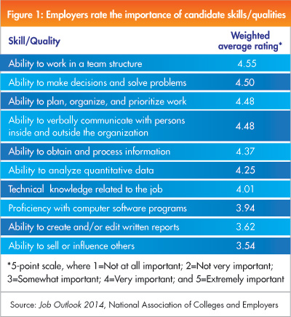

Post Internship Reflection Paper
You will be responsible for writing a 2-3 page paper at the end of your internship showing how these 4 skills were utilized and reflecting on your internship experience. The following questions may be helpful in aiding you to reflect on your internship experience. (You are not limited to these prompts.) Email your reflection paper to Tina MacKenzie (mackenziet@etown.edu) within 1 week of your end date.
- Required: What next steps will you take in your career development or what aspirations do you have for the future?
- Were your 4 learning objectives met? Why or why not?
- What part of your internship was the most rewarding and how does this influence your decisions regarding your future and job/career choice?
- What part of your internship was the least rewarding and how will this influence your decisions regarding your future and job/career choice?
- Discuss how the internship confirmed or stimulated new thinking about your educational and or career direction.
- Based on the internship experience describe 2 or more kinds of work or tasks that you would want or not want to pursue in the future.
- Have you learned about new jobs, careers or career paths as a result of your internship? As a result, how has your internship helped define and/or clarify your career goals/career path?
- Think about the employees and leadership in your environment. (Based on what you have seen and experienced, how will this shape the type of employee or leader that you strive to be?)
- What was your greatest accomplishment or reward? Or, what contribution during your internship fulfills you the most?
- How have you grown from this experience? What was the most important thing you learned about yourself?
- Comment on any team interaction you had. (What was your role on the team? What did you learn from interacting with others as part of a team?)
- What has been your biggest lesson learned during your internship? Were there any surprises during your internship?
- What has been the biggest challenge you encountered at your internship? Were you pushed outside of your comfort zone, and how did you handle the challenge?
- Overall was your internship a worthwhile experience? Please explain why/why not. Based on your internship, are you looking forward to the future?

Student Signature:_________________________________________________

Career Services Signature:___________________________________________

Employer Signature:_________________________________________________

